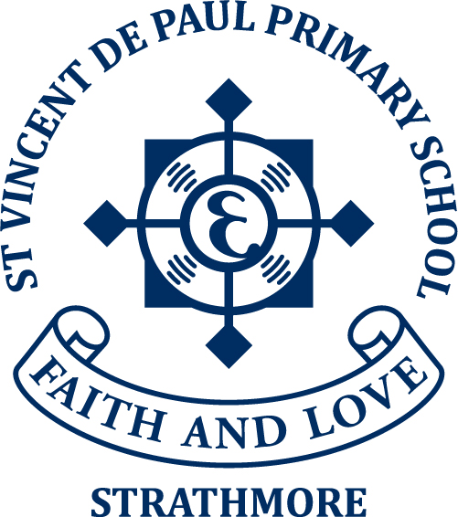

FAMILY COMMITMENT at ST VINCENT de PAUL PRIMARY SCHOOL

At St Vincent de Paul Primary School we recognise that parents have chosen a Catholic Education for their children. Therefore, a shared responsibility is accepted for the further development of the Catholic Ethos of the School Community and its physical facilities.

This responsibility is seen as:

1. a) Development of Christian values within the family as taught by the Catholic
Church.
- Participation at Sunday Mass.
- Seeking out ways to bring the Eucharist into our daily lives.

2. Working together to develop clear and acceptable education objectives and creating an environment which fosters personal growth.

3. Accepting the responsibility to be involved in the school in some capacity.

It is with this in mind that in accepting a place in the school all families accept the on-going responsibility to be involved in some capacity. Please complete this form committing your family to at least one Support Group for the Year 2025.

Family Name: ____________________________ Child’s Name: _________________________

Address: ___________________________________ Mob. No: ___________________________

Email: __________________________________________________________________________

 CLASSROOM PARTICIPATION
Classroom Help
Excursions

- PARENTS ASSOCIATION
Social Development
Fundraising
Special Events

Community Relations

 FAMILY SUPPORT
Support for Parents in times of need by providing a meal

I agree that the details provided in this form can be used by the Parents organisations within the school to make follow up contact with parents.

SIGNED: __________________________________________ DATE: __________________

Please Note: This recognises the commitment of the Family. Both parents are welcome to participate.
Thanking you in anticipation of your support of our school community.

